**1 ] Program to display various components of Visual Basic.**

Private Sub Command1_Click()

MsgBox "This is MsgBox", vbInformation, "MsgBox"

End Sub

Private Sub Form_Load()

Frame1.Caption = "This is Frame"

Text1.Text = "This is TextBox"

Label1.Caption = "This is Label"

Command1.Caption = "This is CommandButton"

Check1.Caption = "This is CheckBox"

Option1.Caption = "This is OptionButton"

End Sub

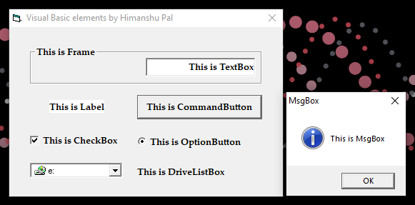

**2 ] Program to get Average of Three Numbers.**

Dim res As Integer

Private Sub button_Click()

res = Val(val1.Text) + Val(val2.Text) + Val(val3.Text)

result.Text = res / 3

End Sub

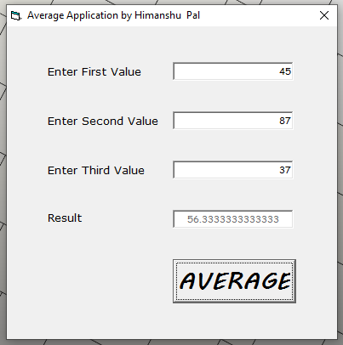

**3 ] Program of Simple Calculator using option selection.**

Private Sub button_Click()

If Addition.Value = True Then

ResultValue.Text = Val(FirstNumberValue.Text) + Val(SecondNumberValue.Text)

ElseIf Subtraction.Value = True Then

ResultValue.Text = Val(FirstNumberValue.Text) - Val(SecondNumberValue.Text)

ElseIf Multiplication.Value = True Then

ResultValue.Text = Val(FirstNumberValue.Text) * Val(SecondNumberValue.Text)

ElseIf Division.Value = True Then

ResultValue.Text = Val(FirstNumberValue.Text) / Val(SecondNumberValue.Text)

ElseIf Remainder.Value = True Then

ResultValue.Text = Val(FirstNumberValue.Text) Mod Val(SecondNumberValue.Text)

End If

End Sub

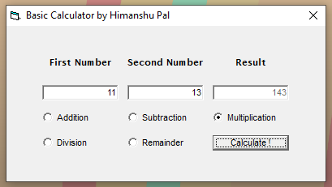

**4 ] Program that takes radius of a Circle from user & prints Area, Diameter & Parameter.**

Dim Rad As Integer

Private Sub button_Click()

If IsNumeric(RadiusField.Text) Then

Rad = Int(RadiusField.Text)

DiameterField.Caption = Rad * 2

ParameterField.Caption = 2 * (22 / 7) * Rad

AreaField.Caption = (22 / 7) * (Rad * Rad)

cmArea.Visible = True

cmDiameter.Visible = True

cmParameter.Visible = True

Else: MsgBox "Radius must be number.", vbCritical, "Error !"

End If

End Sub

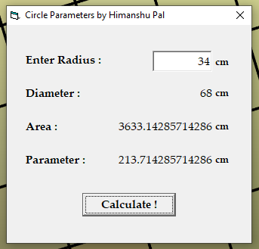

**5 ] Program to Submit user details & display it on another form.**

* **FORM A**

Public StName, Class, OS As String

Public RollNumber, res As Integer

Private Sub ButtonSubmit_Click()

StName = NameField.Text

Class = ClassField.Text

If IsNumeric(RollField.Text) Then

RollNumber = Int(RollField.Text)

If OptionXP.Value = True Then

OS = "Windows XP"

Else: OS = "Windows 7"

End If

res = MsgBox("Are you sure you want to Submit ?", vbYesNo, "Are you Sure ?")

If res = 6 Then

Unload Me

Thanks.Show

End If

Else: MsgBox "Roll Number must be a Number.", vbCritical, "Error !"

End If

End Sub

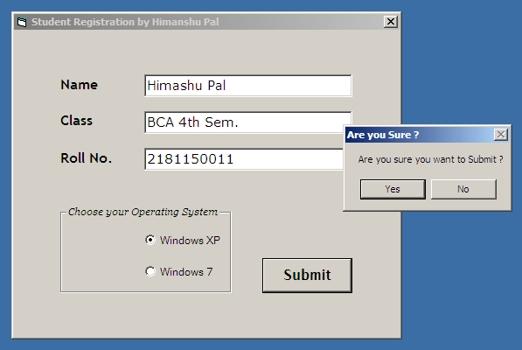

* **FORM B**

Private Sub Form_Load()

SubName.Caption = Details.StName

Class.Caption = Details.Class

RollNumber.Caption = Details.RollNumber

OS.Caption = Details.OS

End Sub

Private Sub Close_Click()

Unload Me

End Sub

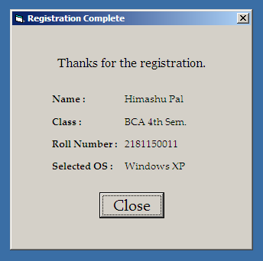

**6 ] Program that serves as an entry point to other programs using combo box selection.**

Dim sel As String

Private Sub Form_Load()

list.AddItem "Average"

list.AddItem "Record"

list.AddItem "Stationary"

list.AddItem "Calculator"

End Sub

Private Sub button_Click()

Select Case list

Case "Average"

Unload Me Average.Show

Case "Record"

Unload Me Details.Show

Case "Stationary"

Unload Me Stationary.Show

Case "Calculator"

Unload Me Calculator.Show

End Select

End Sub

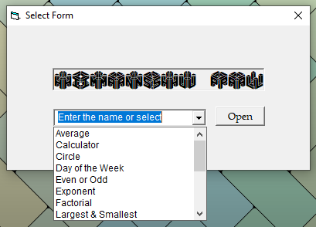

**7 ] Program to check whether a given number is even or odd.**

Private Sub button_Click()

If (Text1.Text Mod 2) = 0 Then

Label2.Caption = "EVEN"

Else: Label2.Caption = "ODD"

End If

End Sub

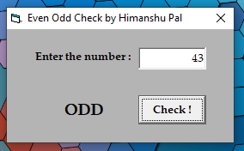

**8 ] Program to find Factorial of a given number.**

Private Sub button_Click()

Dim fact As Long

fact = 1

For x = 1 To Val(Text1.Text)

fact = fact * x

Next x

Label2.Caption = fact

End Sub

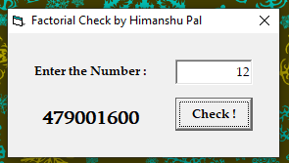

**9 ] Program to find largest & smallest of three given numbers.**

Private Sub buttton_Click()

Dim Smallest, Largest As Integer

If Val(Text1.Text) > Val(Text2.Text) And Val(Text1.Text) > Val(Text3.Text) Then

Largest = Text1.Text

ElseIf Val(Text2.Text) > Val(Text3.Text) And Val(Text2.Text) > Val(Text1.Text) Then

Largest = Text2.Text

ElseIf Val(Text3.Text) > Val(Text1.Text) And Val(Text3.Text) > Val(Text2.Text) Then

Largest = Text3.Text

End If

If Val(Text1.Text) < Val(Text2.Text) And Val(Text1.Text) < Val(Text3.Text) Then

Smallest = Text1.Text

ElseIf Val(Text2.Text) < Val(Text3.Text) And Val(Text2.Text) < Val(Text1.Text) Then

Smallest = Text2.Text

ElseIf Val(Text3.Text) < Val(Text1.Text) And Val(Text3.Text) < Val(Text2.Text) Then

Smallest = Text3.Text

End If

Label7.Caption = Smallest

Label8.Caption = Largest

End Sub

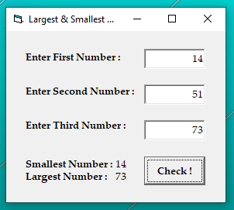

**10 ] Program that raise number to a given exponent.**

Private Sub button_Click()

Label3.Caption = Val(Text1.Text) ^ Val(Text2.Text)

End Sub

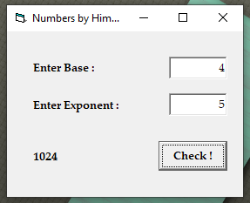

**11 ] Program that takes marks from user & prints total marks, percentage & whether pass or fail.**

Dim s1, s2, s3, s4, s5, res, per As Integer

Private Sub button_Click()

s1 = Val(SubFirstTheory.Text) + Val(SubFirstLab.Text)

s2 = Val(SubSecondTheory.Text) + Val(SubSecondLab.Text)

s3 = Val(SubThirdTheory.Text) + Val(SubThirdLab.Text)

s4 = Val(SubFourthTheory.Text) + Val(SubFourthLab.Text)

s5 = Val(SubFifthTheory.Text) + Val(SubFifthLab.Text)

res = Val(s1) + Val(s2) + Val(s3) + Val(s4) + Val(s5) + Val(LabFirstTheory.Text) + Val(LabSecondTheory.Text)

per = (res * 100) / 700

If per > 40 Then

Final.Caption = "Pass"

Else: Final.Caption = "Fail"

End If

RM.Caption = res

RP.Caption = per

End Sub

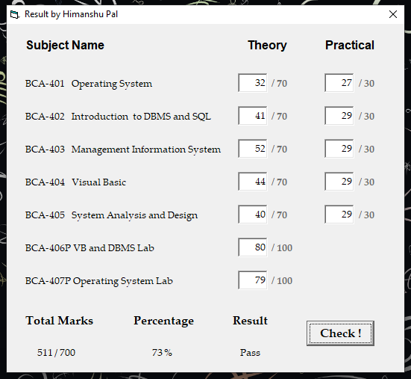

**12 ] Program to check whether a number is prime or not.**

Private Sub button_Click()

If IsNumeric(data.Text) Then

a = Val(data.Text)

For x = 1 To Int(a / 2)

If a Mod x = 0 Then

output.Caption = "Not Prime !"

Else: output.Caption = "Prime !"

End If

Next x

Else: MsgBox "Must be a Number.", vbCritical, "Error !"

End If

End Sub

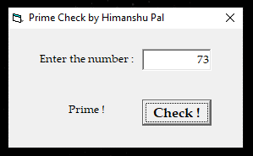

**13 ] Program to check number of passed & failed students among any number of students.**

Dim p, f As Single

Private Sub button_Click()

If IsNumeric(MarksField.Text) Then

If Int(MarksField.Text) > 37 Then

p = p + 1

Else: f = f + 1

End If

Else: MsgBox "No grades allowed.", vbCritical, "Error !"

End If

MarksField.Text = ""

Pass.Caption = p

Fail.Caption = f

End Sub

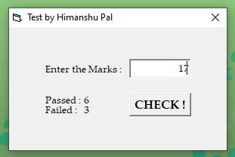

**14 ] Program to provide remarks given the marks of the student.**

Private Sub button_Click()

If IsNumeric(Text1.Text) Then

Select Case Int(Text1.Text)

Case 0 To 27

Label2.Caption = "Pathetic !"

Case 28 To 37

Label2.Caption = "Passed !"

Case 38 To 59

Label2.Caption = "Third Division !"

Case 60 To 84

Label2.Caption = "Second Division !"

Case 85 To 100

Label2.Caption = "First Division !"

Case Else

Label2.Caption = "Un-Possible !"

End Select

Else: MsgBox "No grades allowed.", vbCritical, "Error !"

End If

End Sub

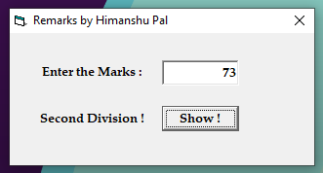

**15 ] Program representing stationary shop that takes price, quantity & provide total bill amount.**

Private Sub PaintBrushQty_Change()

PaintBrushCost.Caption = Val(PaintBrushQty) * 14

End Sub

Private Sub PencilQty_Change()

PencilCost.Caption = Val(PencilQty) * 4

End Sub

Private Sub PenQty_Change()

PenCost.Caption = Val(PenQty) * 7

End Sub

Private Sub EraserQty_Change()

EraserCost.Caption = Val(EraserQty) * 5

End Sub

Private Sub button_Click()

Output.Caption = Int(PencilCost.Caption) + Int(PenCost.Caption) + Int(EraserCost.Caption) + Int(PaintBrushCost.Caption)

End Sub

Private Sub Pencil_click()

If Pencil.Value = 1 Then

PencilQty.Enabled = True

ElseIf Pencil.Value = 0 Then

PencilQty.Text = ""

PencilQty.Enabled = False

End If

End Sub

Private Sub Pen_click()

If Pen.Value = 1 Then

PenQty.Enabled = True

ElseIf Pen.Value = 0 Then

PenQty.Text = "”

PenQty.Enabled = False

End If

End Sub

Private Sub Eraser_click()

If Eraser.Value = 1 Then

EraserQty.Enabled = True

ElseIf Eraser.Value = 0 Then

EraserQty.Text = ""

EraserQty.Enabled = False

End If

End Sub

Private Sub PaintBrush_click()

If PaintBrush.Value = 1 Then

PaintBrushQty.Enabled = True

ElseIf PaintBrush.Value = 0 Then

PaintBrushQty.Text = ""

PaintBrushQty.Enabled = False

End If

End Sub

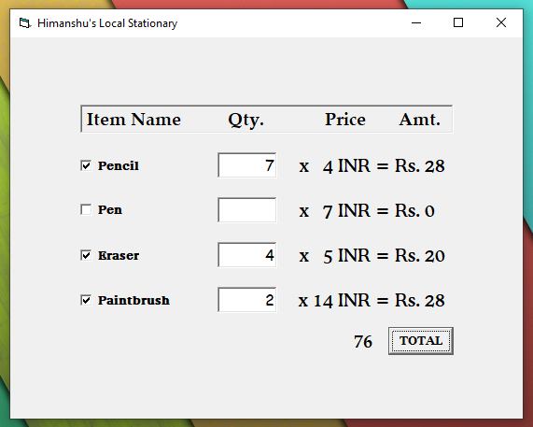

**16 ] Program to find sum of all numbers up to given natural number.**

Private Sub button_Click()

Dim sum As Long

For x = 1 To Val(Text1.Text)

sum = sum + x

Next x

Label2.Caption = sum

End Sub

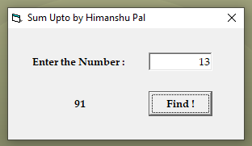

**17 ] Program to convert temperatures among different units.**

Dim K, C, f As Integer

Private Sub button_Click()

If CelciusField.Text = "" And FahField.Text = "" Then

If IsNumeric(KelvinField.Text) Then

K = Int(KelvinField.Text)

FahField.Text = ((9 / 5) * (K - 273)) + 32

CelciusField.Text = K - 273

Else: MsgBox "Temperature must be number.", vbCritical, "Error !"

End If

ElseIf KelvinField.Text = "" And FahField.Text = "" Then

If IsNumeric(CelciusField.Text) Then

C = Int(CelciusField.Text)

FahField.Text = ((9 / 5) * C) + 32

KelvinField.Text = C + 273

Else: MsgBox "Temperature must be number.", vbCritical, "Error !"

End If

ElseIf KelvinField.Text = "" And CelciusField.Text = "" Then

If IsNumeric(FahField.Text) Then

f = Int(FahField.Text)

KelvinField.Text = (5 / 9 * (f - 32)) + 273

CelciusField.Text = (5 / 9) * (f - 32)

Else: MsgBox "Temperature must be number.", vbCritical, "Error !"

End If

End If

End Sub

Private Sub clear_Click()

FahField.Text = ""

KelvinField.Text = ""

CelciusField.Text = ""

End Sub

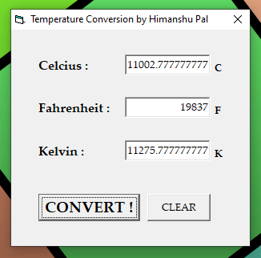

**18 ] Program to get the name of the day by providing day number.**

Private Sub Command1_Click()

If IsNumeric(Text1.Text) Then

Select Case Text1.Text

Case 1

Label2.Caption = "It's Monday."

Case 2

Label2.Caption = "It's Tuesday."

Case 3

Label2.Caption = "It's Wednesday."

Case 4

Label2.Caption = "It's Thursday."

Case 5

Label2.Caption = "It's Friday."

Case 6

Label2.Caption = "Its's Saturday."

Case 7

Label2.Caption = "It's Sunday."

Case Else

MsgBox "Week-Day must be in range of 1-7.", vbCritical, "Error !"

End Select

Else: MsgBox "Week-Day must be a Number.", vbCritical, "Error !"

End If

End Sub

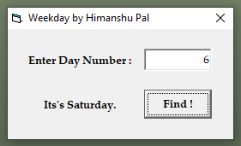

**19 ] Program to calculate Simple Interest.**

Private Sub button_Click()

Label4.Caption = (Val(Text1.Text) * Val(Text2.Text) * Val(Text3.Text)) / 100

End Sub

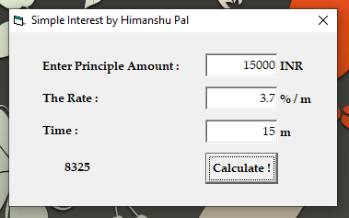

**20 ] Program to check if a given year is Leap Year or Not.**

Private Sub button_Click()

If Text1.Text Mod 4 = 0 Then

Label2.Caption = "LEAP"

Else: Label2.Caption = "NORMAL"

End If

End Sub

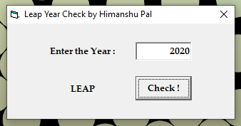

**21 ] Program to Swap two values entered by User.**

Dim val1, val2, temp

Private Sub button_MouseDown(button As Integer, Shift As Integer, X As Single, Y As Single)

val1 = Text1.Text

val2 = Text2.Text

temp = val1

val1 = val2

val2 = temp

Text1.Text = val1

Text2.Text = val2

Label1.Caption = "After Swapping :"

End Sub

Private Sub button_MouseUp(button As Integer, Shift As Integer, X As Single, Y As Single)

val1 = Text1.Text

val2 = Text2.Text

temp = val1

val1 = val2

val2 = temp

Text1.Text = val1

Text2.Text = val2

Label1.Caption = "Initial Values :"

End Sub

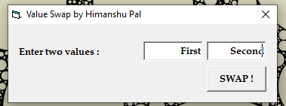

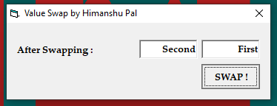

**22 ] Program to check if a given number is Perfect or Not.**

Private Sub button_Click()

Dim num, pr As Integer

num = Val(Text1.Text)

For X = 1 To num - 1

If num Mod X = 0 Then

pr = pr + X

End If

Next X

If num = pr Then

Label2.Caption = "PERFECT"

Else: Label2.Caption = "NOT PERFECT"

End If

End Sub

